**Project Development Phase**

**Sprint – 2**

|  |  |
| --- | --- |
| Date | 15 November 2022 |
| Team ID | PNT2022TMID45183 |
| Project Name | AI Based Discourse for Banking Industry |
| Maximum Marks | 8 Marks |

**Create Action for Savings Account Queries:**

In this phase savings account creation and types of savings account information’s are feed to the assistant.

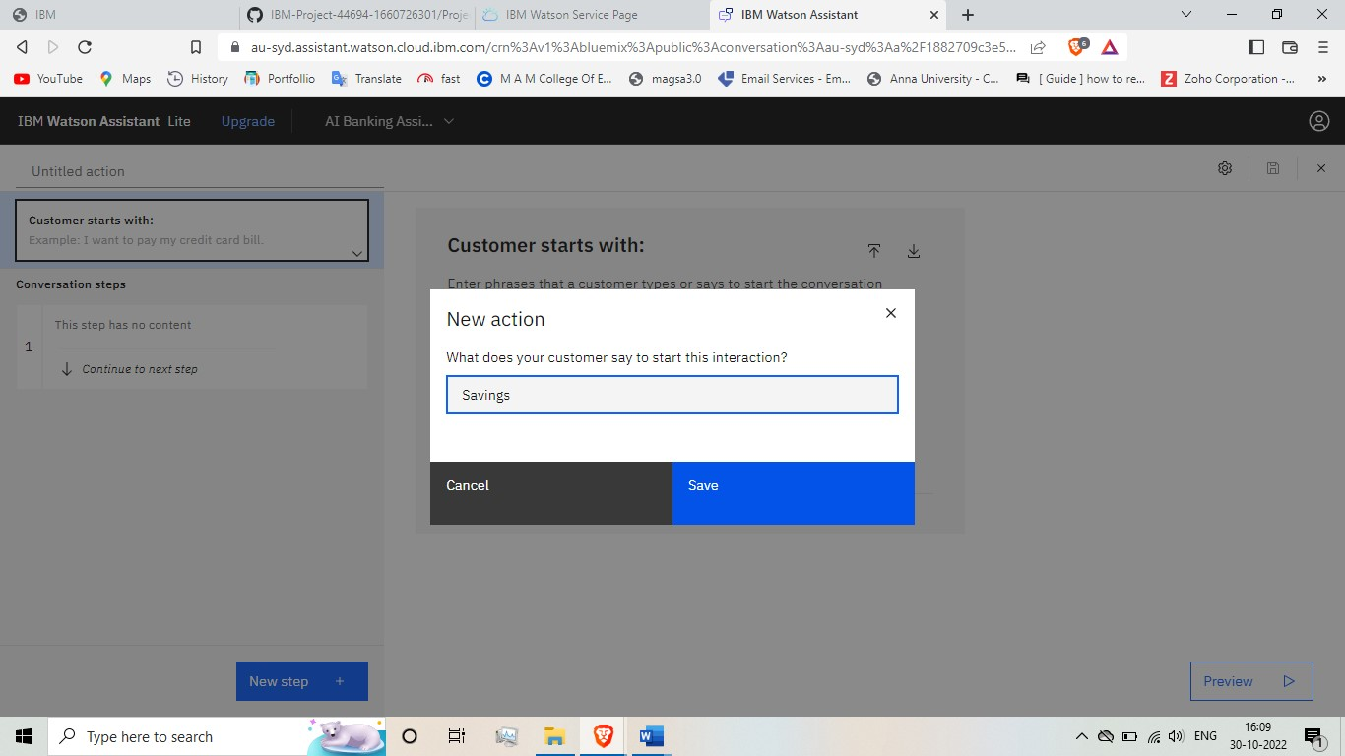

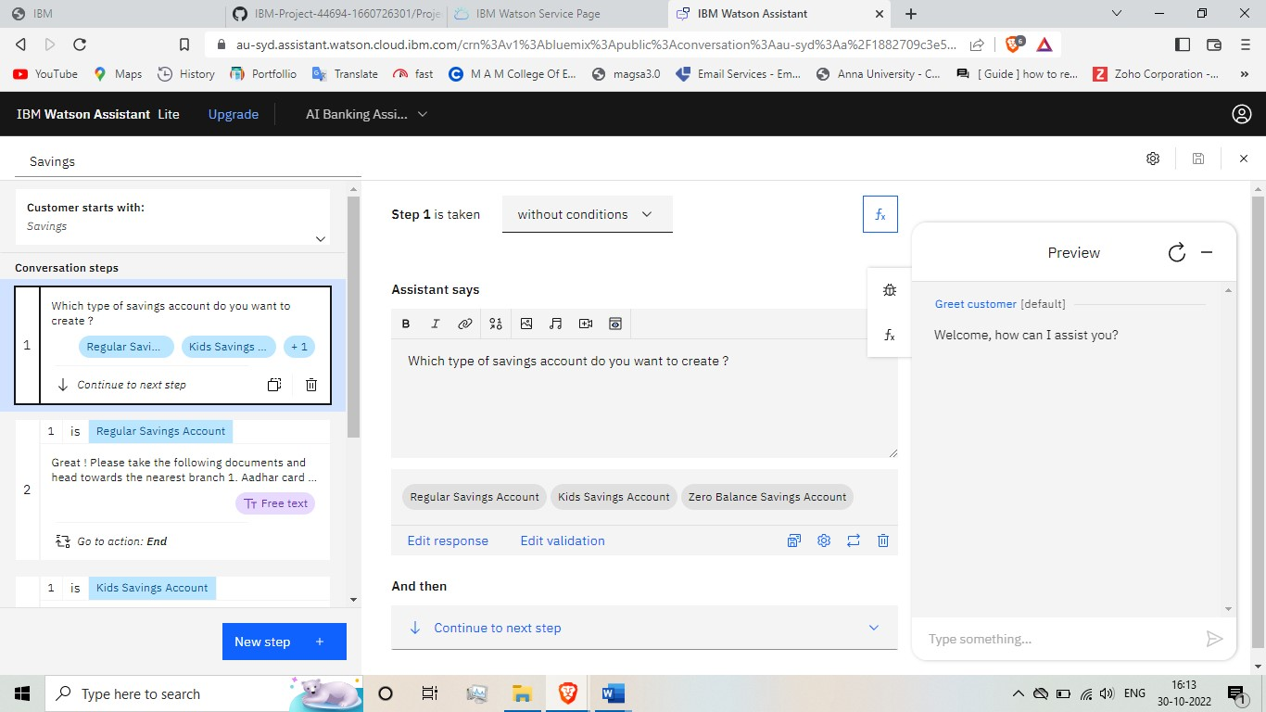

**Create Action for Current Account Queries:**

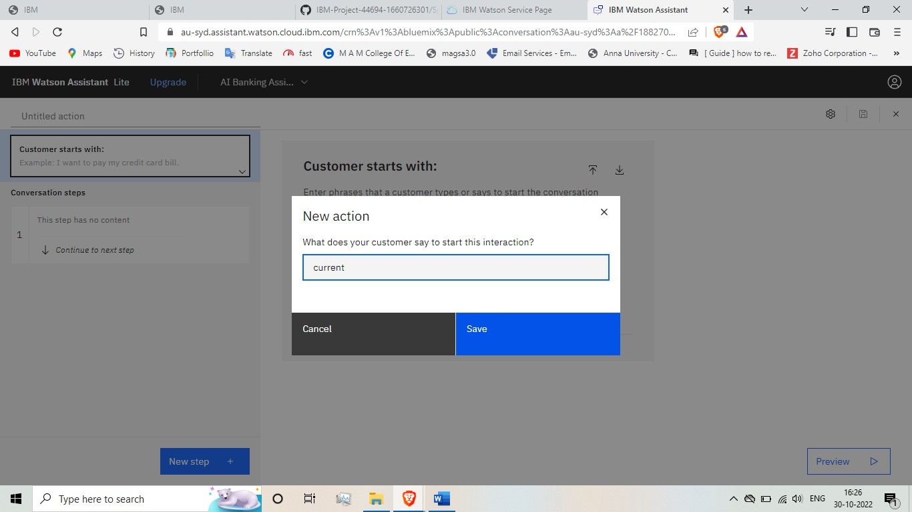

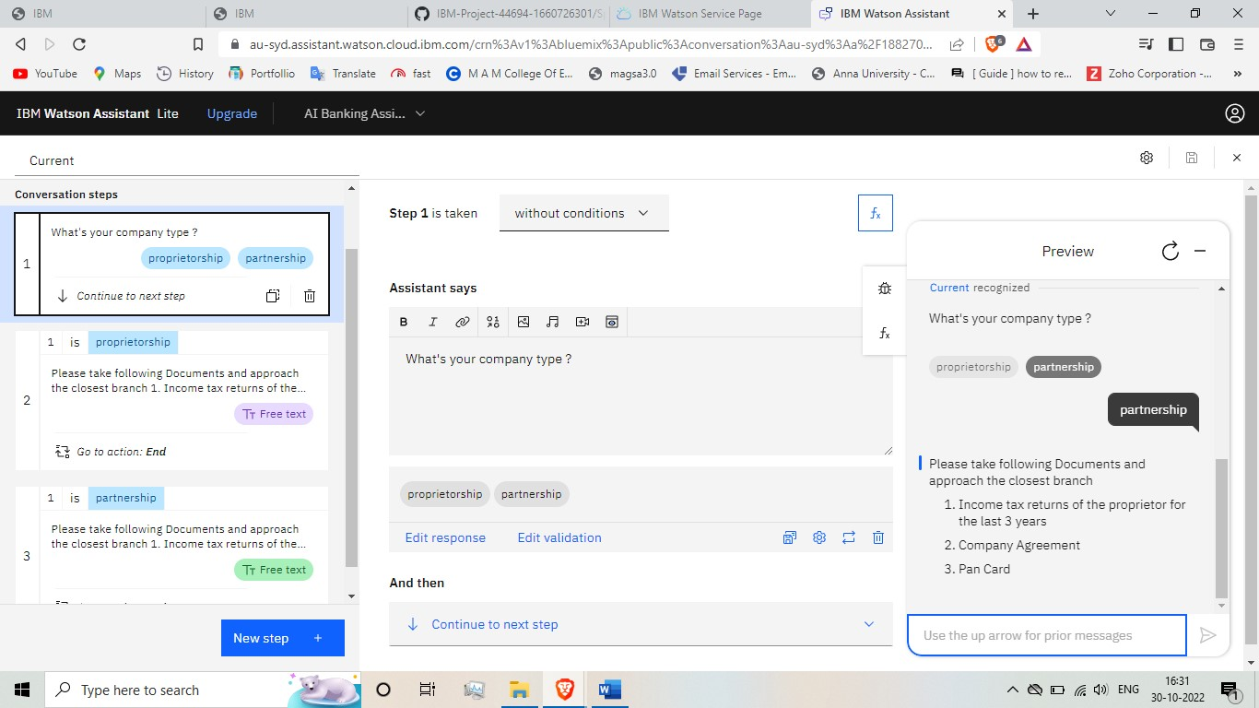

**Create Action for Loan Queries:**

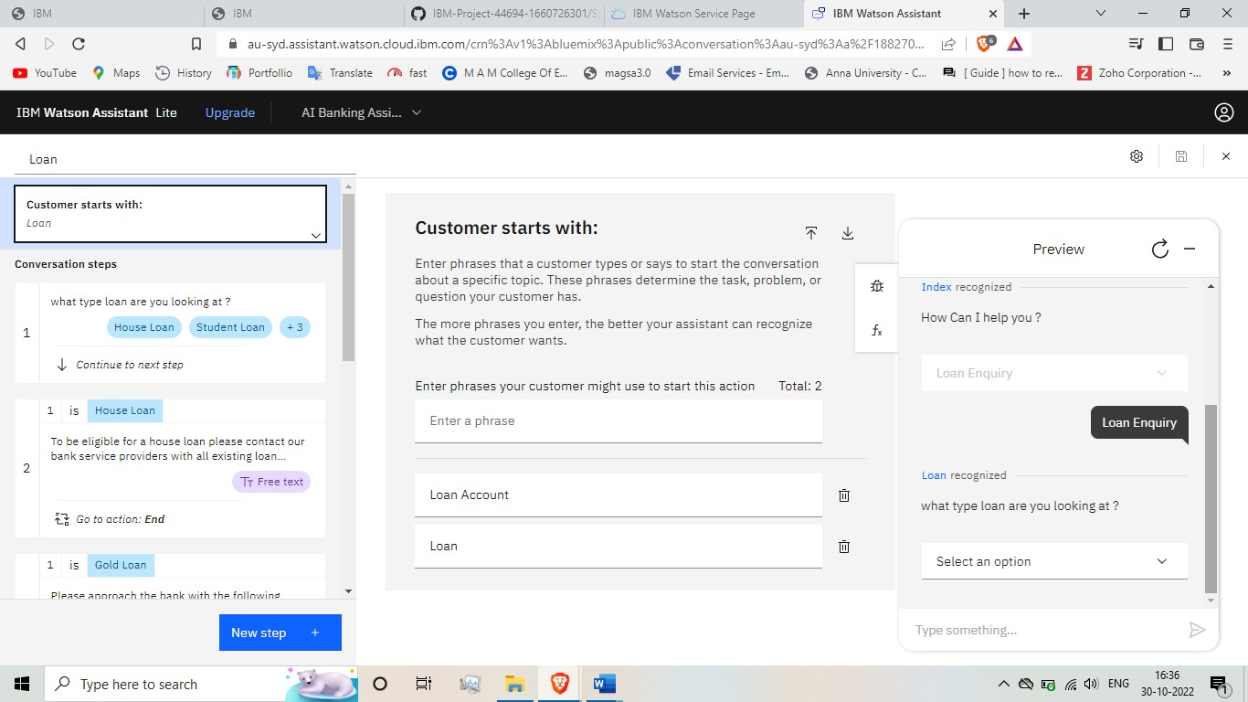

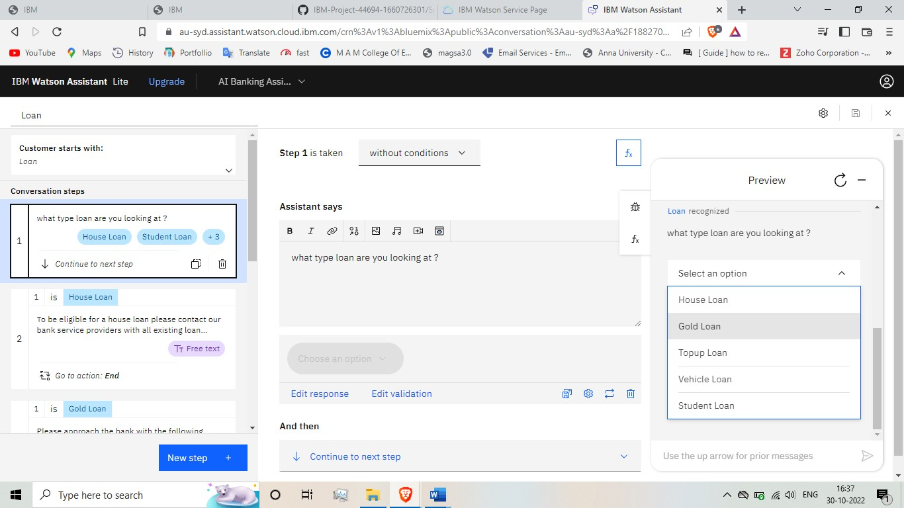

**Create Action for General Queries:**

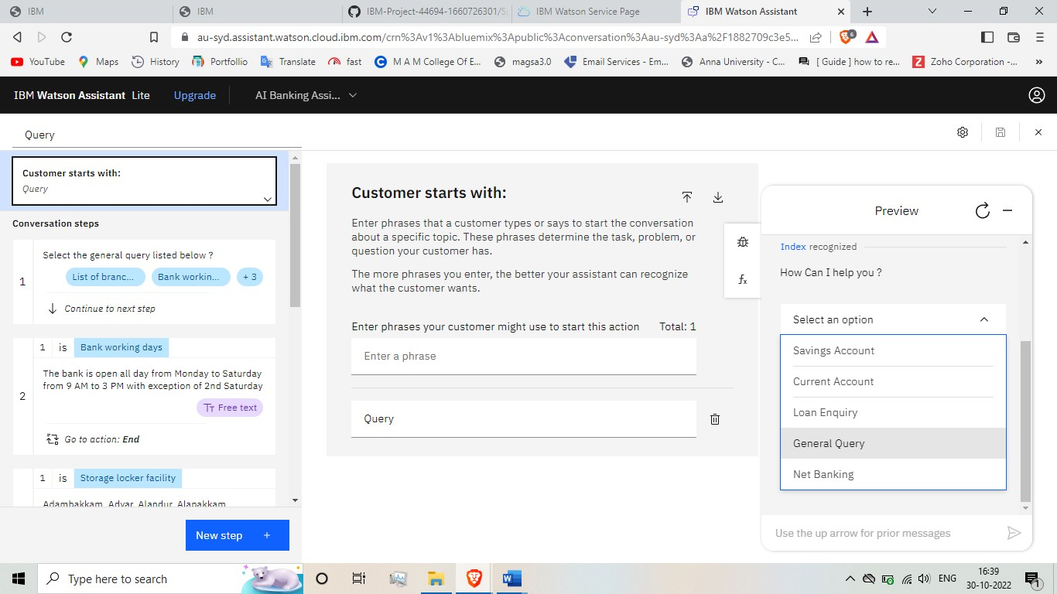

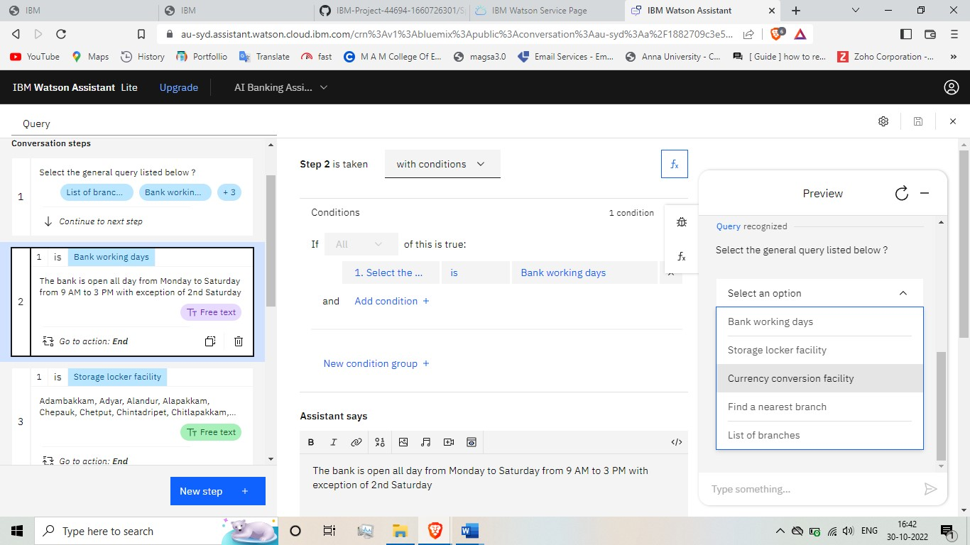

**Create Action for Net banking Queries:**

